**PRACTICAL NO 6:**

**CODE:**

**CREATION OF DATABASE AND TABLE:**

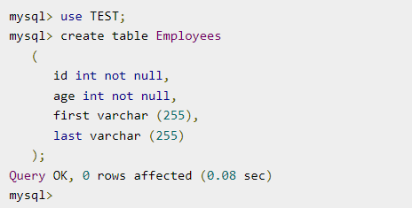

**INSERT INTO TABLE:**

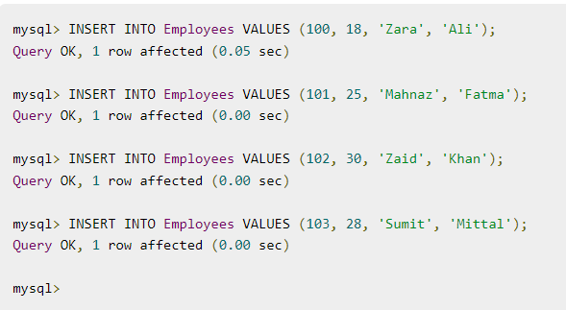

**FETCH AND DISPLAY THE DATA IN TABLE**:

<%@ page import = "java.io.*,java.util.*,java.sql.*"%>

<%@ page import = "javax.servlet.http.*,javax.servlet.*" %>

<%@ taglib uri="http://java.sun.com/jsp/jstl/core" prefix = "c"%>

<%@ taglib uri="http://java.sun.com/jsp/jstl/sql" prefix = "sql"%>

<html>

<head>

<title>SELECT Operation</title>

</head>

<body>

<sql:setDataSource var = "snapshot" driver = "com.mysql.jdbc.Driver"

url = "jdbc:mysql://localhost/TEST"

user = "root" password = ""/>

<sql:query dataSource = "${snapshot}" var = "result">

SELECT * from Employees;

</sql:query>

<table border = "1" width = "100%">

<tr>

<th>Emp ID</th>

<th>First Name</th>

<th>Last Name</th>

<th>Age</th>

</tr>

<c:forEach var = "row" items = "${result.rows}">

<tr>

<td><c:out value = "${row.id}"/></td>

<td><c:out value = "${row.first}"/></td>

<td><c:out value = "${row.last}"/></td>

<td><c:out value = "${row.age}"/></td>

</tr>

</c:forEach>

</table>

</body>

</html>

**OUTPUT:**

